MongoDB HW – Warren Payne

Task 1

1. create db
   1. 
2. drop db
   1. 
3. create collection
   1. 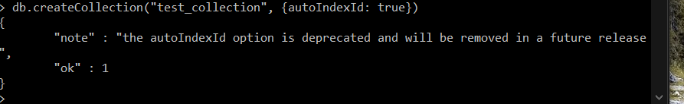
4. drop collection
   1. 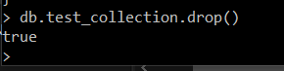
5. insert document into collection
   1. 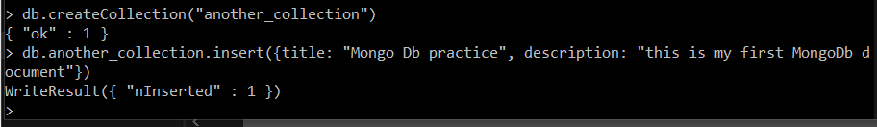
6. query the document
   1. 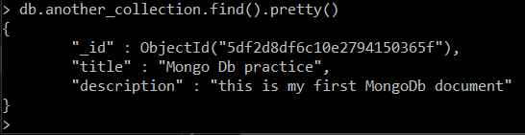
7. update a document
   1. 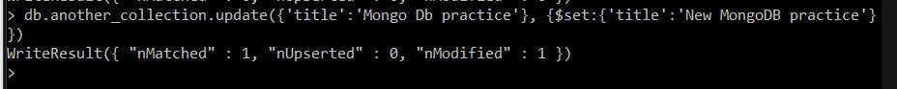
8. delete a document
   1. 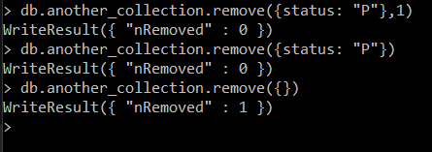

Task 2

1. count on “Sandwich” in the name
   1. 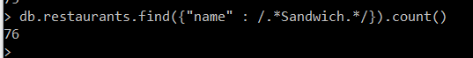
2. list French cuisine in Queens by name only
   1. 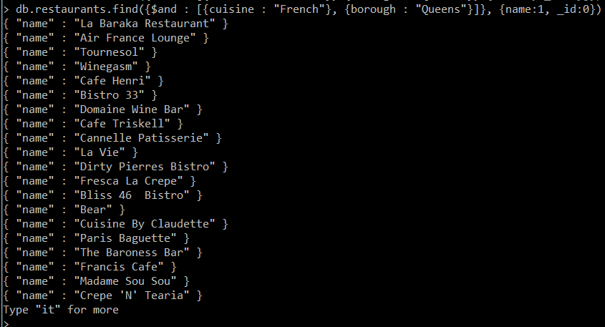
3. Descending count of Italian eateries by borough
   1. 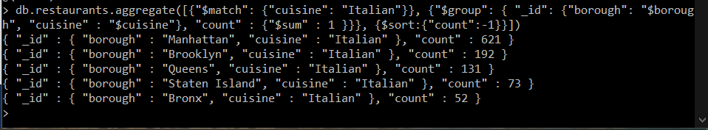
4. List top 5 German restaurants in Manhattan by their sum of scores in descending order
   1. 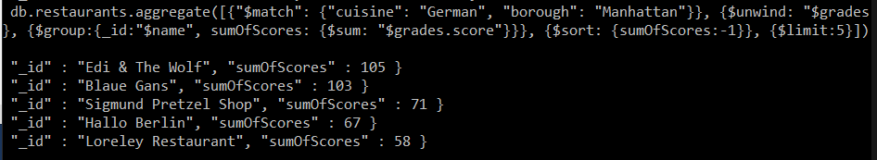
5. Find the restaurants within the coordinates that have a score greater than 75
   1. 